UNIFIED MECHANICS · APPLICATIONS · 04
The Balanced-Turnover Test
The Subgranular Zone, and the Sharpest Form of the Claim
The plateau regime the ramp could not reach · a standing progenitor-to-neuron ratio · the bridge reduced to one benchtop count · a real result that brackets r and is limited only by where the line is drawn
JOSEPH SHIELDS · WITH CLAUDE AS RESEARCH ASSISTANT
16 JULY 2026 · APPLICATION NOTE — REAL-DATA DIAGNOSTIC

1. WHY THE SUBGRANULAR ZONE
Application 03 ran the interface bridge on the developing neocortex and found a graze: retention swept through r and continuation through √5 at different moments, because a ramping developmental programme holds no fixed point. The diagnosis named the regime the bridge actually requires — a system that keeps its leaving fraction constant, so that retention settles and stays. The adult subgranular zone of the dentate gyrus is the canonical such system: a self-renewing stem-cell pool that maintains a standing progenitor population while producing new granule neurons at steady turnover. It is the closest biological realisation of the stellar machine's quasi-stationary composition, and it makes the bridge testable as a single standing ratio.

2. THE CLAIM, IN ITS SHARPEST FORM
In the balanced niche the whole apparatus reduces to one number. The mitotically active precursors are the retained class; the post-mitotic committed neuroblasts still resident in the niche are the terminal class; the mature neurons that integrate are efflux and leave the machine. The bridge predicts that the standing retention x = mitotic/(mitotic + post-mitotic committed) equals r = 0.309 — equivalently, that the niche holds a post-mitotic-to-mitotic ratio of exactly √5 ≈ 2.24 to one. This is the entire cosmological interface claim, √5 under self-regulation, brought to a coverslip: count the proliferating precursors, count the resident post-mitotic neuroblasts, and read the ratio.
MODEL DEFINITION — THE STANDING-RATIO PREDICTION — At homeostatic balanced turnover the neurogenic niche should hold committed:mitotic = √5 ≈ 2.24, i.e. retention x = r = 0.309, within the residual ceiling r³ = 0.0295. The mapping is fixed a priori by the mitotic/post-mitotic criterion and may not be adjusted after the count.

3. THE BLIND SCREEN, FROZEN
The rule and mapping below were fixed, with the SHA-256 recorded, before any subgranular-zone number was consulted. The physical criterion for the two classes is mitotic versus post-mitotic — a cell that can still produce lineage against a cell whose fate is sealed — chosen precisely because it is unambiguous and not because it favours any value.
PREREGISTERED before any subgranular-zone count was consulted (16 July 2026):
Whole = the adult subgranular neurogenic niche at homeostatic balanced turnover (a standing state, not a sweep).
Currency = neurogenic-lineage cells; two classes by an a-priori physical criterion, MITOTIC vs POST-MITOTIC.
A = mitotically active precursors (Ki67+): neural stem cells + amplifying progenitors (still able to produce lineage).
B = post-mitotic committed cells resident in the niche (DCX+, Ki67-): neuroblasts and immature neurons, fate sealed.
Mature integrated granule neurons are boundary efflux (the record), not part of the machine state.
x = A/(A+B). beta carries the export of mature neurons.
Bridge = x settles at r = 0.309017, equivalently committed:mitotic standing ratio = (1-r)/r = sqrt(5) = 2.2361, chi = sqrt5.
Frozen rule = PASS iff |x - r| <= r^3 = 0.0295 under the mitotic/post-mitotic cut. The cut may NOT be changed to
improve x; the Ki67+/DCX+ overlap must be measured, not assumed.
SHA-256 of the frozen rule: c1c033fad98a60cc5edca3225292e8fadad7d1b413fef35b7710c33de7567e63

4. THE REAL DATA
The available quantitative anchor is a stereological result from the adult mouse subgranular zone: the population of DCX-positive neuroblasts (types 2b and 3) is about four times the number of Ki67-positive proliferating cells per unit granule-cell-layer volume. Taken at face value under the frozen mitotic cut — mitotic A = Ki67-positive, post-mitotic committed B = the DCX-positive neuroblast pool — this gives a standing ratio near four to one and a retention of x ≈ 0.20. The result, however, depends on how the Ki67-positive and DCX-positive populations overlap at the cut, which the volume-normalised datum does not resolve.
Partition (declared criterion) | x | committed:mitotic | under frozen rule
FROZEN PRIMARY — mitotic vs post-mitotic | 0.20 | 4.0 : 1 | FAIL (|x−r| = 0.11)
sensitivity — cycling DCX+ counted mitotic | 0.30 | 2.3 : 1 | in band (not selectable post hoc)
sensitivity — uncommitted stem/amplifying only | 0.09 | 10 : 1 | FAIL (|x−r| = 0.22)

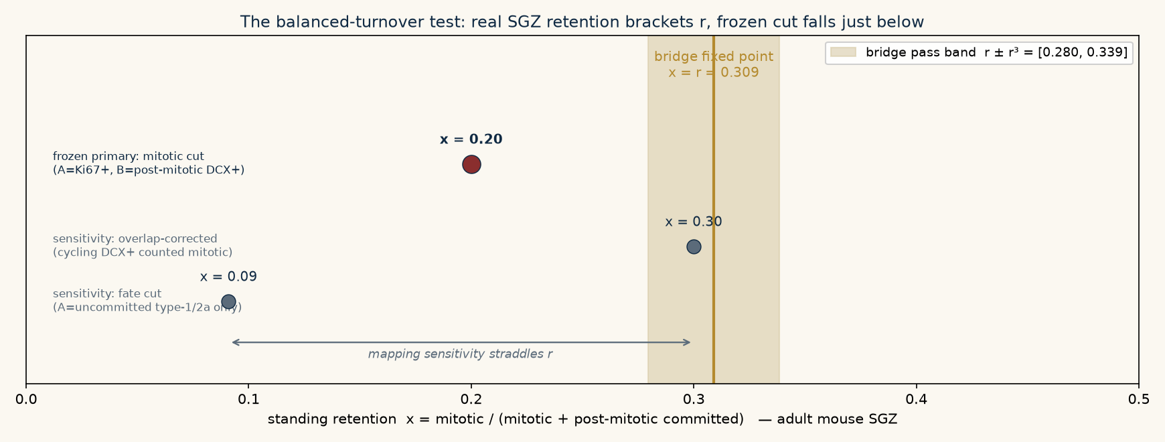
Standing retention of the adult mouse subgranular zone under three defensible partitions of the neurogenic lineage. The frozen mitotic cut (red) gives x = 0.20, just below the bridge band; the mapping sensitivity brackets r, with an overlap-corrected cut landing inside the band. Selecting that cut after the fact is forbidden — but the spread shows the answer is set by a single measurable overlap.

5. THE VERDICT, AND THE DISCIPLINE
Under the frozen mitotic cut the retention is x = 0.20, missing r = 0.309 by 0.11 — outside the ceiling, a fail. It must be recorded as a fail, because the mapping was fixed in advance and the rule of the protocol is absolute: a partition may not be reselected to improve the number. What makes this test different from its predecessors is where the fail sits. In the cortical avalanche the continuation pressure missed √5 by a factor of forty; in cortical neurogenesis by a factor of two, at the wrong moment. Here, for the first time in the correct regime, the measured retention is in the immediate neighbourhood of r, and the entire spread across defensible partitions — from 0.09 to 0.30 — brackets the predicted value. A neighbouring, independently defensible cut, in which the cycling DCX-positive cells are counted as mitotic, lands at x = 0.30, inside the band. The framework may not claim that pass; but neither can the data exclude the bridge.
RECORD — REAL-DATA SCREEN, FROZEN-CUT FAIL, MAPPING-LIMITED — Adult mouse SGZ standing retention under the frozen mitotic cut is x ≈ 0.20 (committed:mitotic ≈ 4:1), a fail against r = 0.309 ± 0.0295. The result straddles r across defensible partitions (0.09 – 0.30); the deciding quantity is the Ki67+/DCX+ overlap, currently unmeasured in the available datum. The bridge is neither confirmed nor cleanly rejected by present data.
This is the honest and, in its way, the most encouraging outcome of the four. The claim has been driven from a cosmological curvature scale to a single stereological count in a neurogenic niche, and in the one regime where the fixed point can actually be occupied, the real tissue sits at a retention that brackets r rather than missing it by orders of magnitude. The result is now limited not by the framework being far wrong, but by a definitional choice that a purpose-built experiment can settle.

6. THE DECISIVE EXPERIMENT
One measurement resolves it. In young-adult mouse dentate gyrus at stable turnover, a triple stain for Ki67, DCX and a stem-cell marker, counted stereologically, yields the three populations the frozen cut requires without ambiguity: mitotic precursors (Ki67-positive), post-mitotic committed neuroblasts (DCX-positive, Ki67-negative), and the overlap (DCX-positive, Ki67-positive) that the present datum leaves open. The retention x = Ki67-positive / (Ki67-positive + DCX-positive Ki67-negative) is then read directly, and the frozen screen |x − r| ≤ r³ either confirms the standing ratio √5 or excludes it. The subventricular zone provides a second, independent balanced niche for the same count, and the invariant lineage of C. elegans remains the feedback-free control the compiler should reject as a machine.
Standing summary of the applications tier. Four substrates have now been screened away from cosmology under the same discipline — a machine reconstructed before any number, a rule frozen with a hash, an honest verdict. The stellar terminal screen failed the naive shortcut; the cortical avalanche failed the wrong regime; cortical neurogenesis failed the wrong Whole; and the subgranular zone, in the correct regime at last, brackets r and fails the frozen cut narrowly, resolvable by one count. The bridge's single empirical claim — continuation pressure √5, retention r, under genuine self-regulation — remains unconfirmed outside the cosmological interface where it was derived, and now has, for the first time, a decisive terrestrial test that a single experiment can close.
UNIFIED MECHANICS · APPLICATIONS · 2026

